**Announcements Feedbacks**

1. Modal does not hide it showed error on all levels in only condition when you add back to back announcements without refreshing the page but when you add announcements after refreshing the page there is no error at all.

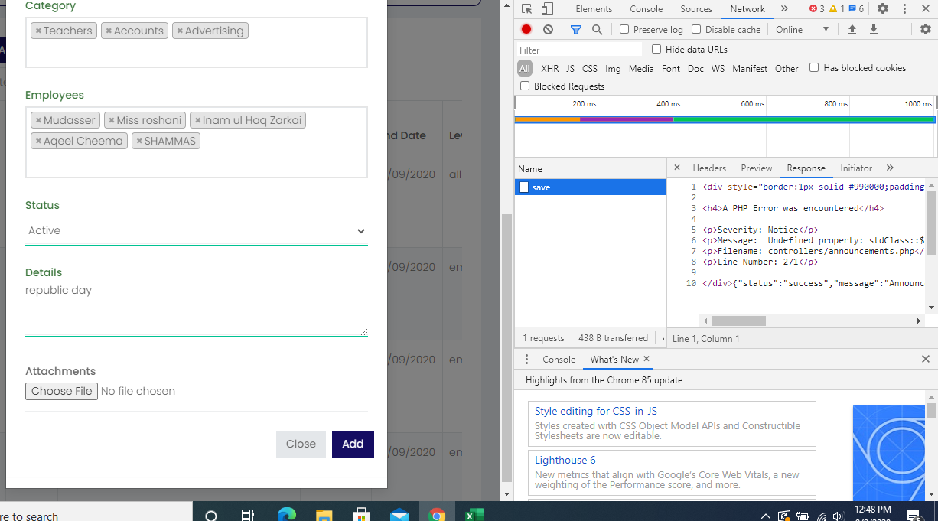

1. Detailed page of announcement showed error when you add announcement without the attachments.

